Fire Investigator 1 - Assignment #6
Utah Fire and Rescue Academy

Situation:

Analyze the building systems presented in the attached pictures.

Assignment:

Examine each photograph that depicts a different building system to determine their involvement, if any, with the fire’s origin, cause, or responsibility. Determine if the building service revealed in the photograph would require an expert to properly inspect and examine the specific building system. The candidate should focus on accomplishing the skills listed below:

• Identify the building service
• Recognize the candidate’s limitation to accurately inspect the building service
• Identify the activity being conducted at the time of taking the photograph
• Recognize and analyze fire patterns
• Determine if the building service was a victim of the ensuing fire or potentially involved in the ignition scenario
• Identify whether the building service may have been the origin for the fire
• Recognize and preserve evidence relating to the building service and the potential cause and/or responsibility for the fire

Requirements:

1. Use a word processing or other data management software program to write the report. Double space blocks of typed text.
2. The report must be grammatically correct with no spelling errors.
3. Technical terms should be explained for clarification.

State skill # 6,8

Photo 1

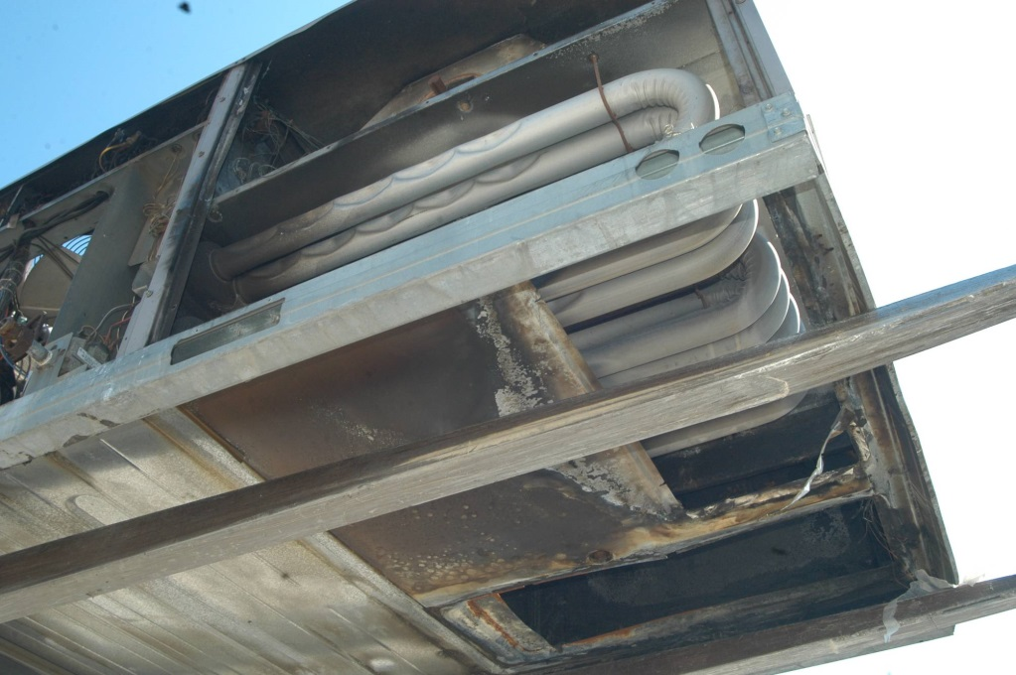

Photo 2

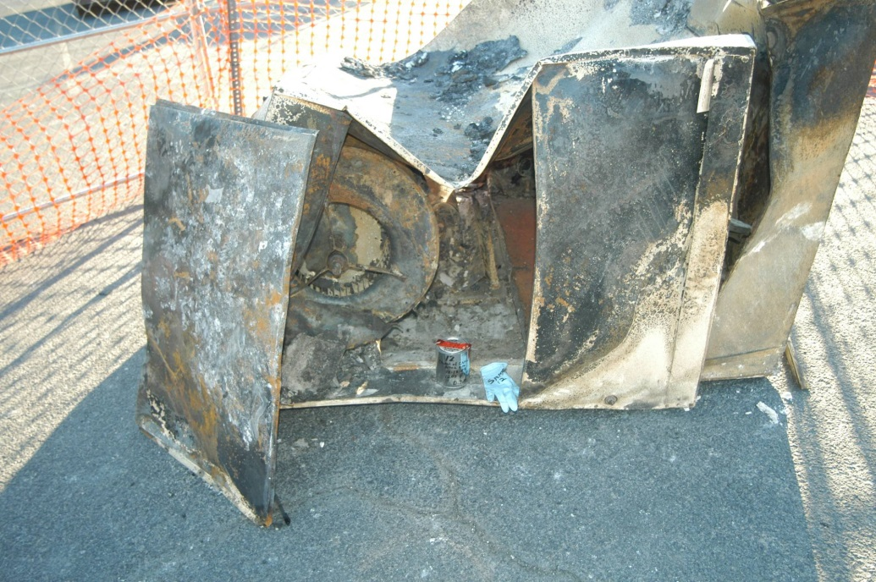

Photo 3
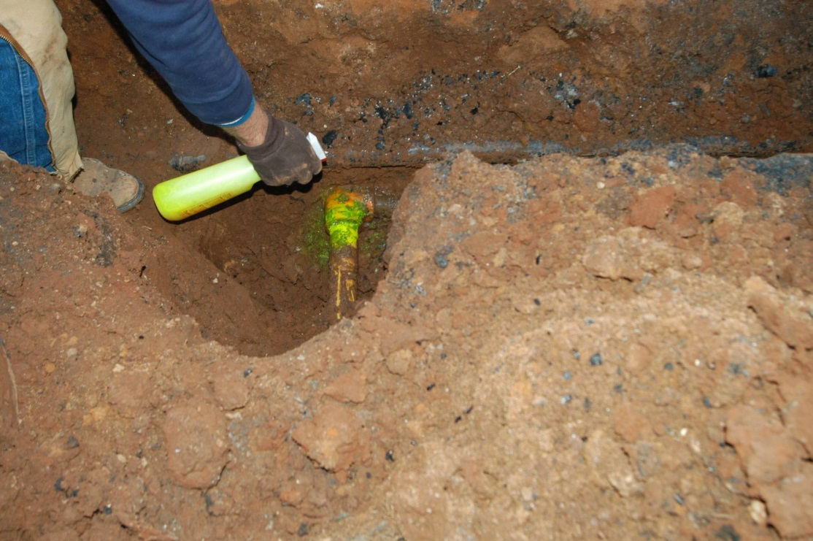

Photo 4

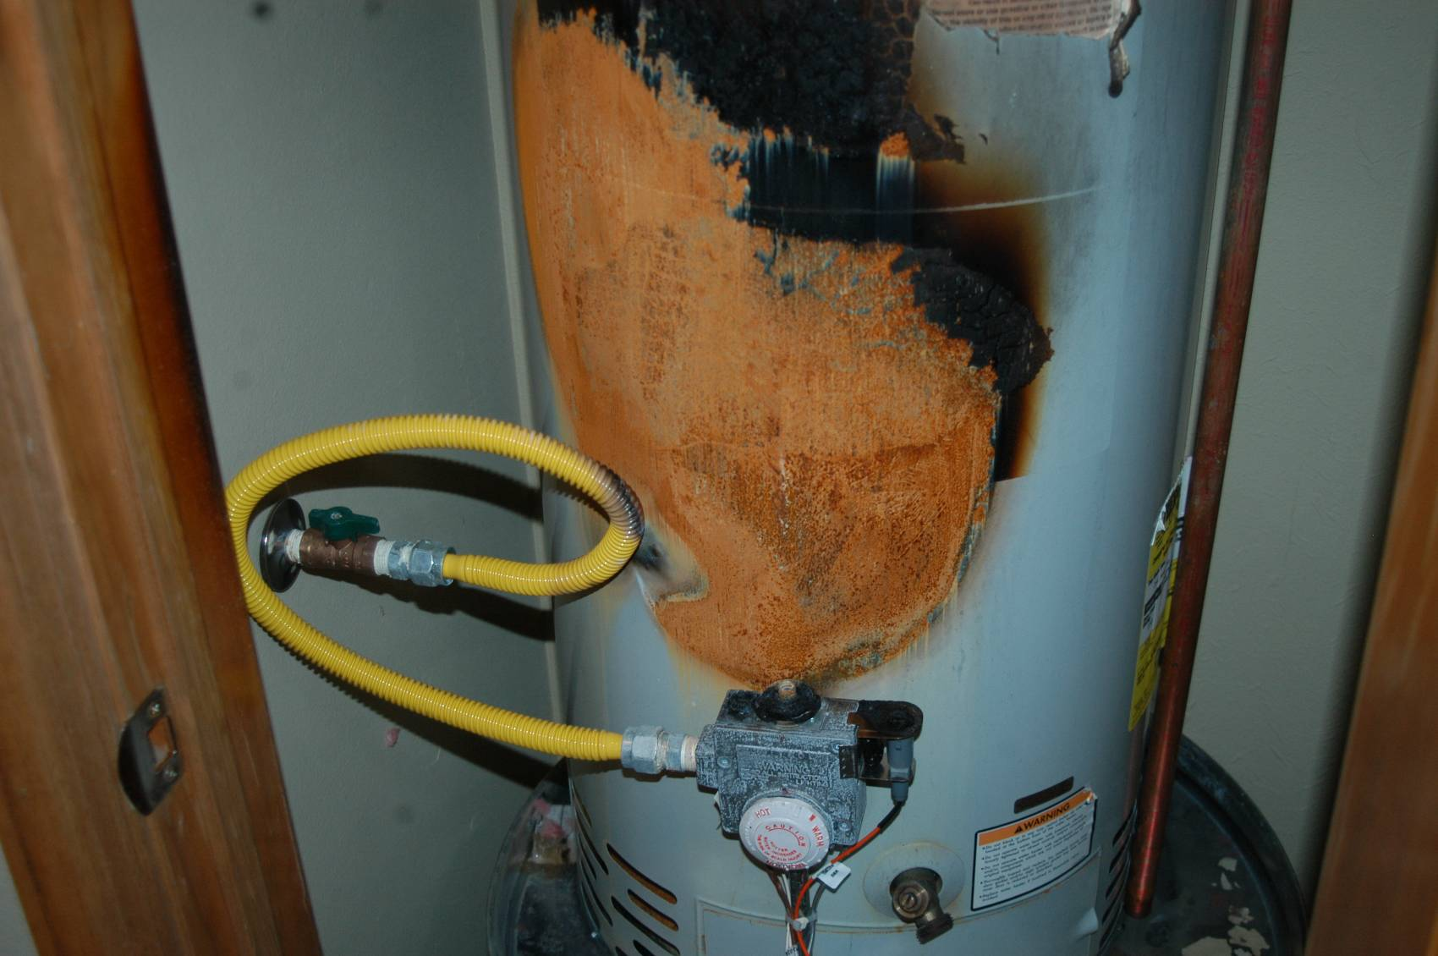

Photo 5
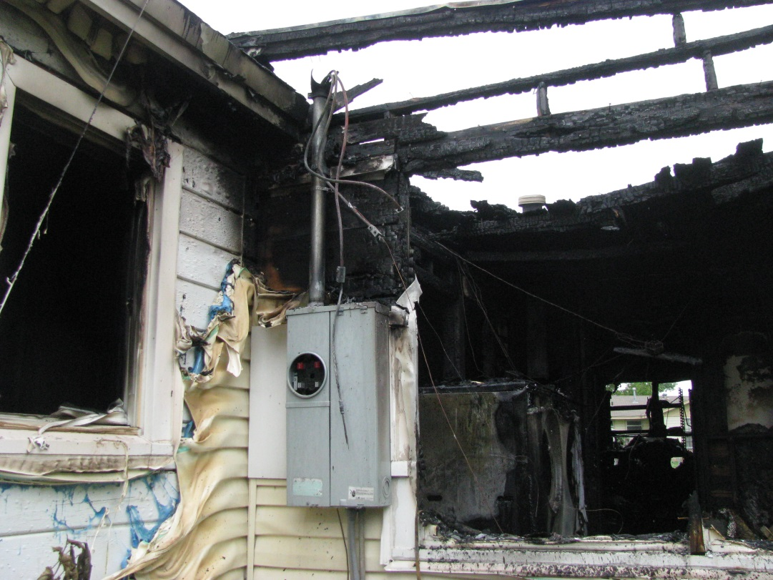
Photo 6
