Fire Investigator 1 - Assignment # 7
Utah Fire and Rescue Academy

Situation:

You are assigned to determine the electrical potential of an appliance.

Assignment:
Analyze each photo and answer the questions that follow. Be sure to utilize Ohm’s Law formulas for each question.

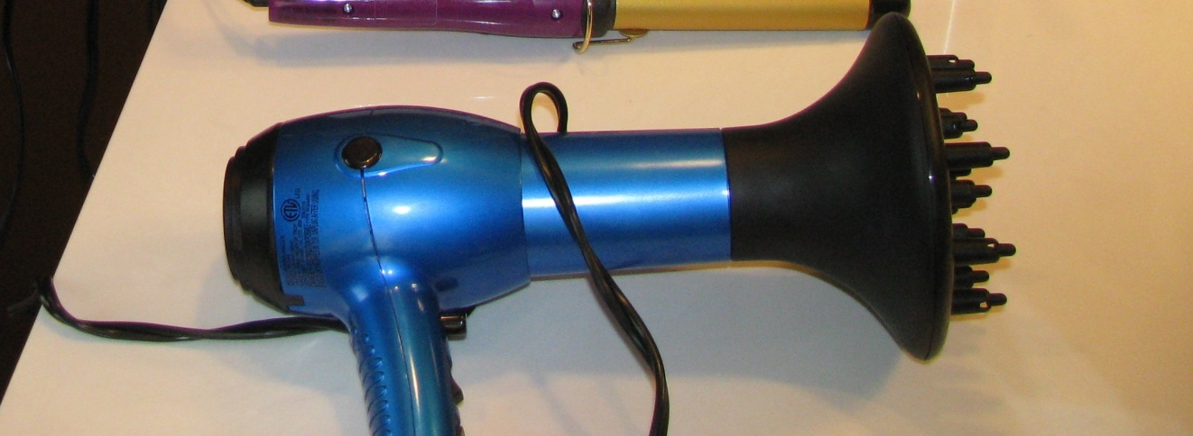

1. For a 1200 watt appliance operating on 120 volts, determine the current (amperes).

2. For the appliance above, determine the resistance (ohms).

3. From your determination of current and resistance in the previous questions, determine the power (watts).

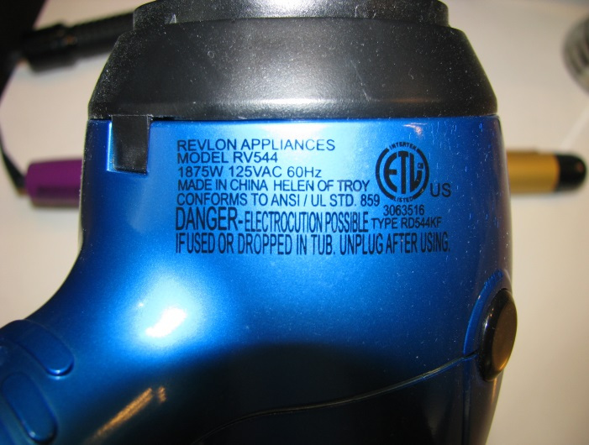
4. Determine the watts and voltage for this appliance.

5. Determine the current (amperes) for this appliance.

6. Determine the resistance for this appliance.

Requirements:

1. Use a word processing or other data management software program to write the report. Double space blocks of typed text.
2. The report must be grammatically correct with no spelling errors.
3. Technical terms should be explained for clarification.

State skill #

