Fire Investigator 1 - Assignment #9 Safety
Utah Fire and Rescue Academy

Situation:

You have been assigned to investigate the four fires shown in the attached pictures. Your first duty is to ensure scene safety and secure the scene. How would you ensure scene safety and secure the scene in each case.

Assignment:

Analyze each photograph. Answer each question.

- How would you secure the scene?
- What are the potential hazards?
- How would you mitigate the hazards to provide a safe scene for the fire investigation?
- What are the safety concerns for the egress and ingress?
- How would you mitigate the egress and ingress concerns?

Requirements:

1. Use a word processing or other data management software program to write the report. Double space blocks of typed text.
2. The report must be grammatically correct with no spelling errors.
3. Technical terms should be explained for clarification.

State skill # 1,2,3,4

Photo 1 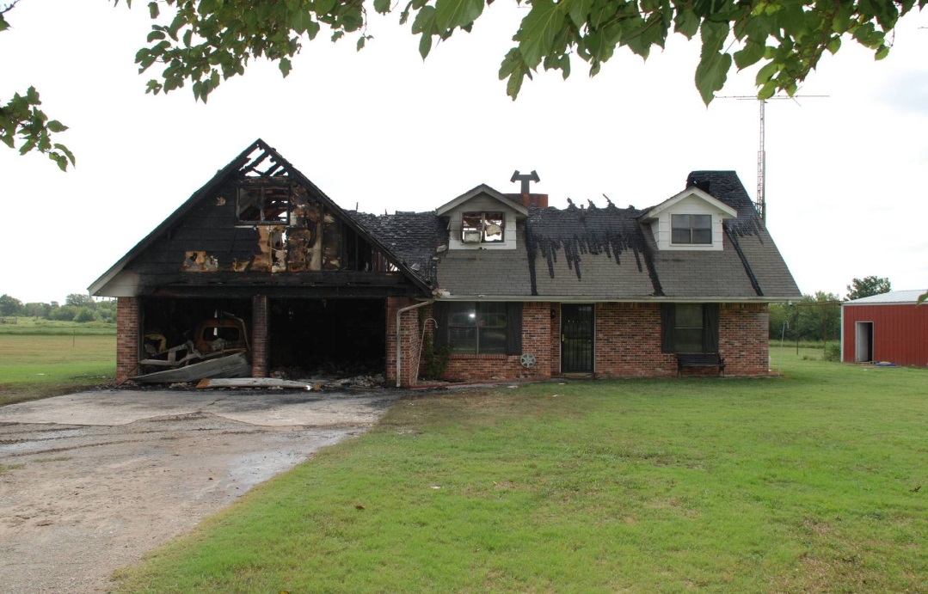

Photo 2
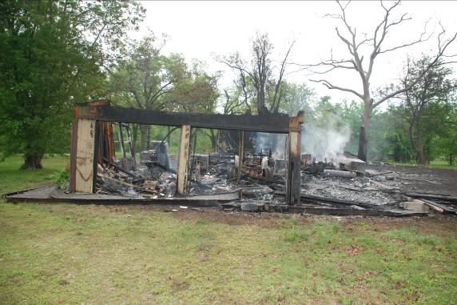
Photo 3

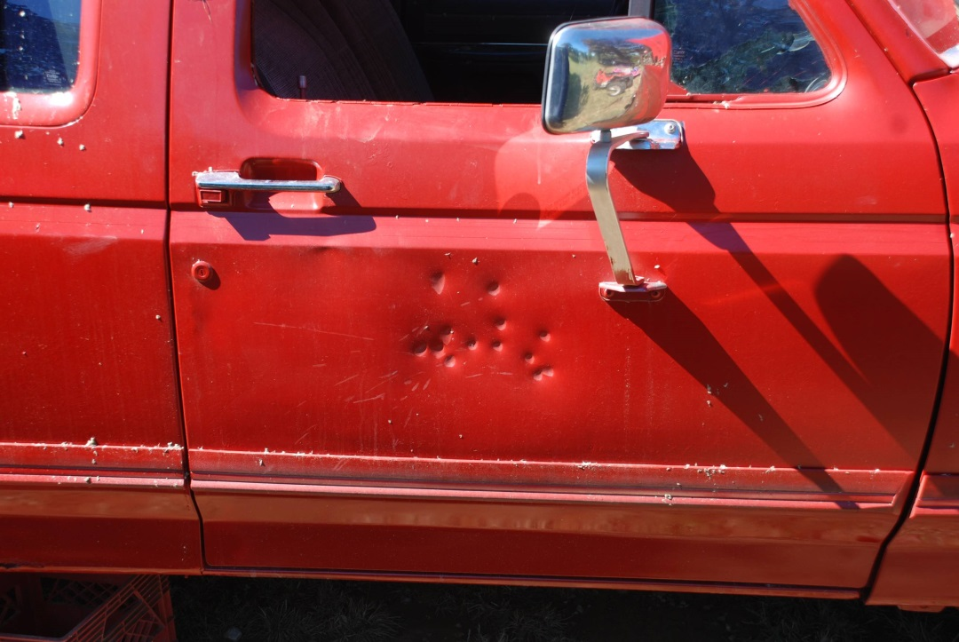

Photo 4
