Fire Investigator 1 - Assignment #5
Utah Fire and Rescue Academy

Situation:

Basics of Building Construction as It Relates to the Fire Investigator

Assignment:

Analyze each photograph. On a separate sheet of paper, write the different building construction types that are depicted in each of the photographs. Additionally, in photos that contain fire damage, the candidate should analyze the fire damage and the associated effects the fire had on the structure. Answer/Address the following statements:
a. Provide a safety survey relating to the interior of the structure
b. Identify any potential evidence that may need to be preserved for additional examination
c. Identify the building construction types
d. Provide how the building and its services functioned during the fire incident
e. Conduct an analysis of all fire patterns
f. Analyze the area of greatest fire damage
g. Identify the vapor density of the fuel involved in this fire/explosion incident
h. Recognize each item depicted within the photographs
i. Analyze the performance of the fire and life safety devices
j. Determine the performance of air handling units and other building services of the structures

Photo 1

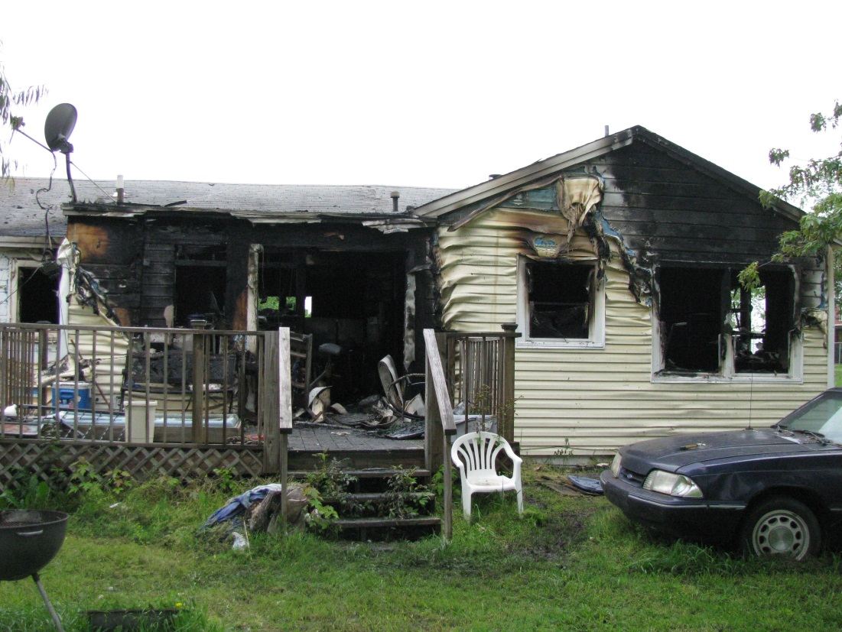

Photo 2

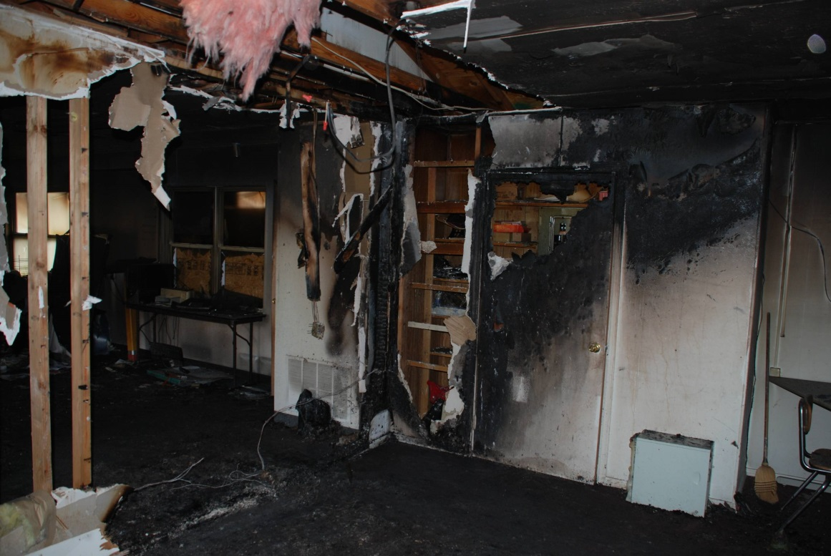

Photo 3

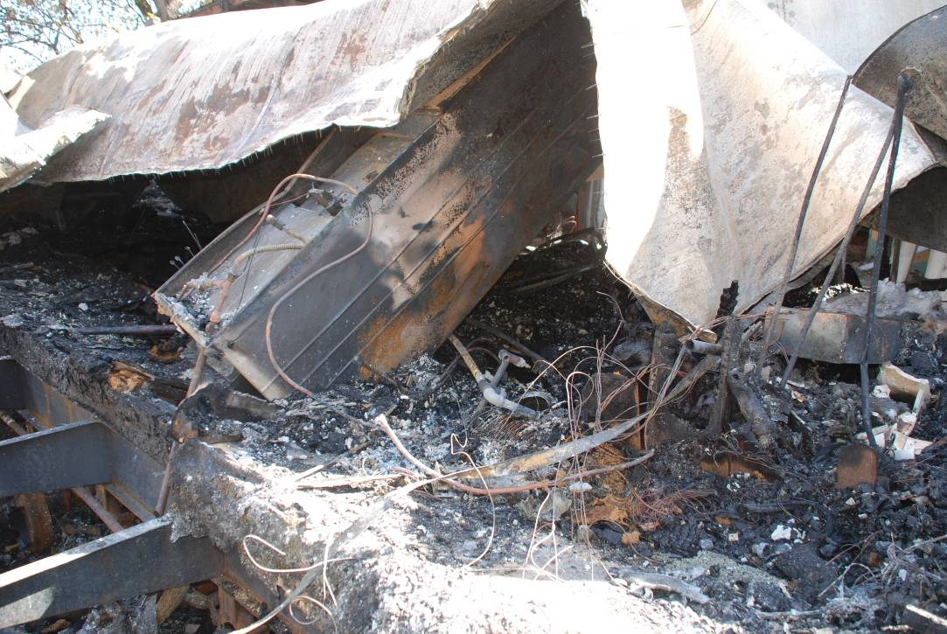

Photo 4

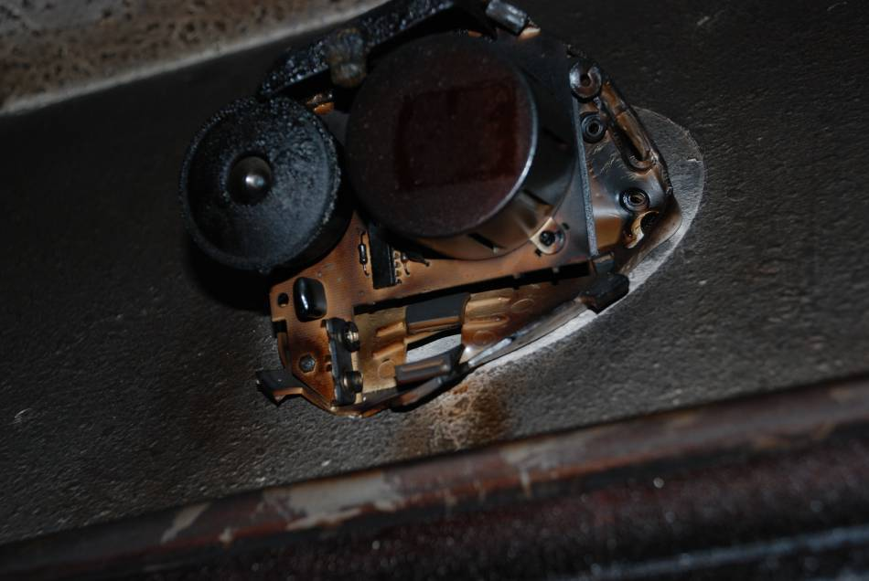
Photo 5

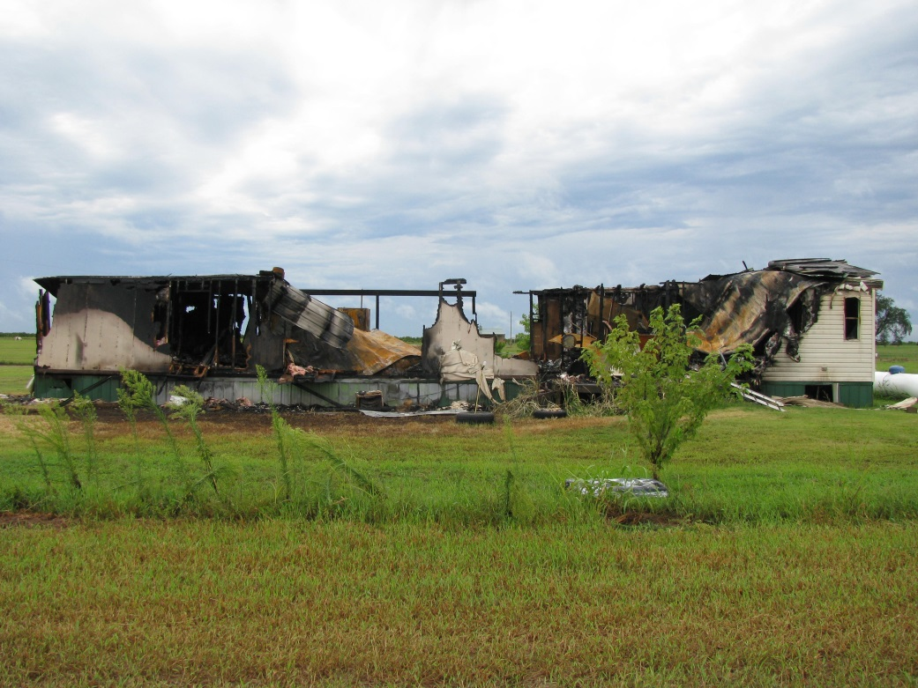

Photo 6

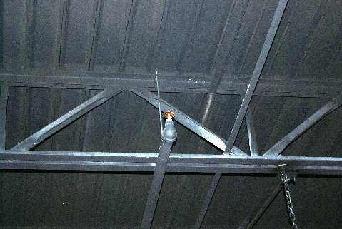
Requirements:

1. Use a word processing or other data management software program to write the report. Double space blocks of typed text.
2. The report must be grammatically correct with no spelling errors.
3. Technical terms should be explained for clarification.

State skill # 2,3

