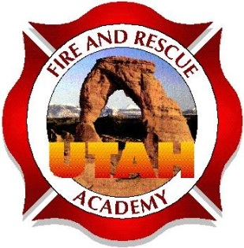

Utah Fire and Rescue Academy
Re: Student Participation
Dear Student,
Thank you for participating in a UFRA training course. It is the goal of UFRA to provide a training course that will help the students and department obtain the needed information for them to be safe and successful in the fire service. In order to provide the best learning environment and opportunity for success for all students, the following guidelines are provided to you for your review.

Student requirements:
- Arrive on time and stay until the class is dismissed by the instructor.
- Return from breaks within the allotted time specified by the instructor.
- Complete all reading and work assignments on or before the date specified by the instructor and outlined in the course syllabus. Any assignments or projects not completed and turned in to the instructor, on or before the designated date in the syllabus will not be accepted. Failure to complete and submit 2 or more assignments will result in dismissal from the class.
- Use proper language at all times in the classroom and all training events related to the course. Crude, demeaning or comments that may be construed as offensive shall not be used or referred to at any time.
- Always be professional in their communication and actions at all times. Students who are deemed to be disruptive to the class will be excused from participation.
- Be respectful of beliefs, national origin, gender differences and religious convictions.
- Demonstrate respect for differing views or opinions.
- Attend each class. Class attendance of 80% for each class is required to attend and participate in the certification testing process.
- Respect the facility and all equipment at all times. The classroom is to remain clean and free of trash or debris.
- Insure the classroom, drill ground and all equipment will be returned to its proper location and condition before the class is dismissed.
- No cellphones and pagers during the class unless required by their departments for contact in the event of an emergency. If these items are required, they should be placed on vibrate, silent mode or the lowest possible volume so as to not disrupt the other students.
- Report and document all injuries that occur during the training period immediately to the instructors.

By signing you acknowledge and understand the Student Requirements

___________________________________________________ __________________
Signature Date

Thank you,
Utah Fire and Rescue Academy.

