Scenario #3
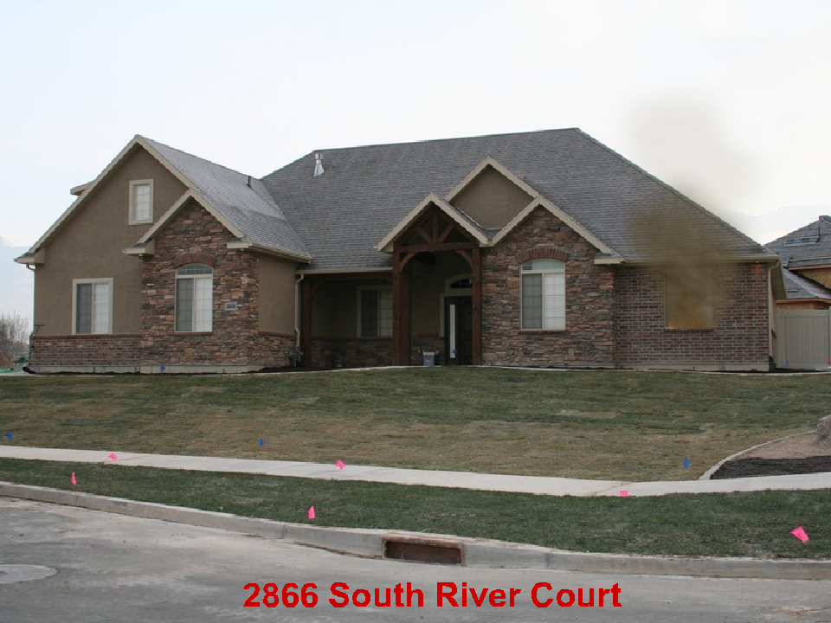

2 Story Residential 75’ x 50’ 20 % involved. Exposure 40’ away on the “D” side.
August 20 8:00 am Monday

What are your Incident Priorities?
_______________________________________
_______________________________________
_______________________________________

Initial Report with Strategy
______________________________________________________________________
______________________________________________________________________
______________________________________________________________________
______________________________________________________________________
______________________________________________________________________
______________________________________________________________________
Fire Flow Required
______________________________________________________________________

Initial assignments for your engine, 2 additional engines, 1 truck, 1 ambulance
_____________________________________________________________________
_____________________________________________________________________
_____________________________________________________________________
_____________________________________________________________________
_____________________________________________________________________
_____________________________________________________________________
_____________________________________________________________________

