Scenario #6
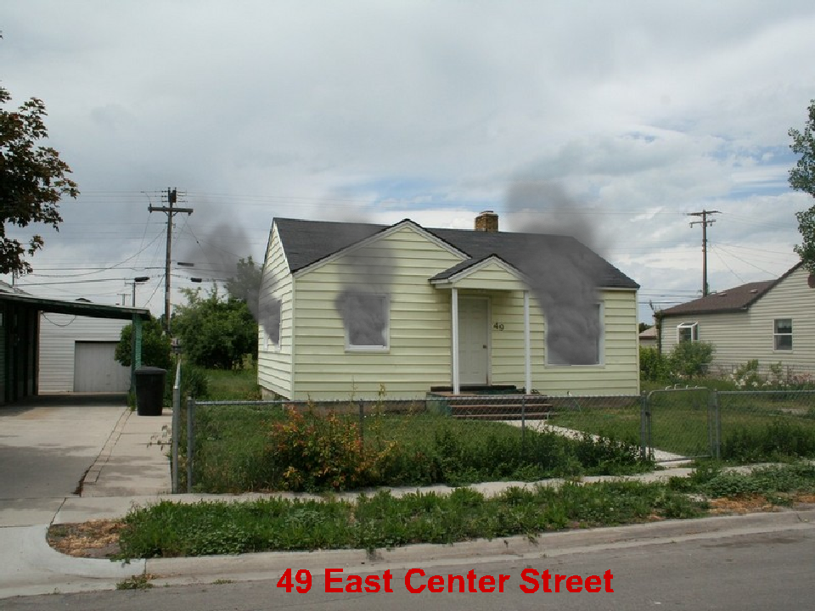

1 Story Residential 30’ x 40’ 75 % involved. Exposure 20’ away on the “B” side.
May 17 2:00 am Saturday.

What are your Incident Priorities?
_______________________________________
_______________________________________
_______________________________________

Initial Report with Strategy
______________________________________________________________________
______________________________________________________________________
______________________________________________________________________
______________________________________________________________________
______________________________________________________________________
______________________________________________________________________
Fire Flow Required
______________________________________________________________________

Initial assignments for your engine, 2 additional engines, 1 truck, 1 ambulance
_____________________________________________________________________
_____________________________________________________________________
_____________________________________________________________________
_____________________________________________________________________
_____________________________________________________________________
_____________________________________________________________________
_____________________________________________________________________

