Scenario #1

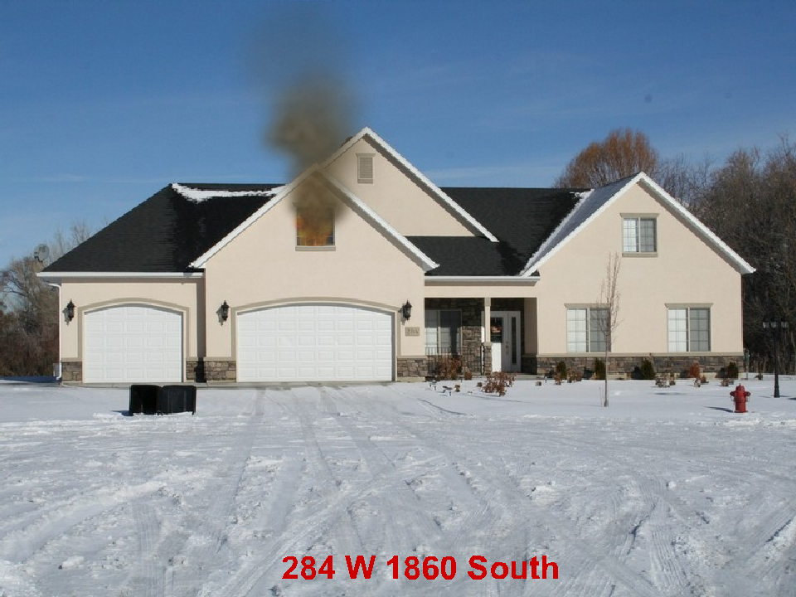

2 Story Residential 80’ x 50’ 25% involved. Exposure 25’ away on the “C” side
December 15 7:00 pm Friday.

What are your Incident Priorities?
_______________________________________
_______________________________________
_______________________________________

Initial Report with Strategy
______________________________________________________________________
______________________________________________________________________
______________________________________________________________________
______________________________________________________________________
______________________________________________________________________
______________________________________________________________________
Fire Flow Required
______________________________________________________________________

Initial assignments for your engine, 2 additional engines, 1 truck, 1 ambulance
_____________________________________________________________________
_____________________________________________________________________
_____________________________________________________________________
_____________________________________________________________________
_____________________________________________________________________
_____________________________________________________________________
_____________________________________________________________________

