Scenario #4
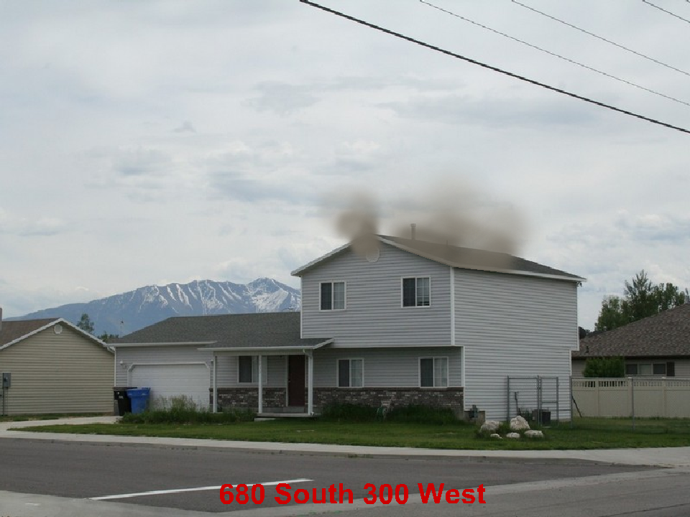

2 Story Residential 50’ x 30” 25% involved. Exposure 35’ away on the “B” side.
April 15 3:00 pm Wednesday.

What are your Incident Priorities?
_______________________________________
_______________________________________
_______________________________________

Initial Report with Strategy
______________________________________________________________________
______________________________________________________________________
______________________________________________________________________
______________________________________________________________________
______________________________________________________________________
______________________________________________________________________
Fire Flow Required
______________________________________________________________________

Initial assignments for your engine, 2 additional engines, 1 truck, 1 ambulance
_____________________________________________________________________
_____________________________________________________________________
_____________________________________________________________________
_____________________________________________________________________
_____________________________________________________________________
_____________________________________________________________________
_____________________________________________________________________

