Long Elevator Statement

I am ___(your name)_____ from ___(your company)______.
We help our clients____(client goal)_______
through ___(your product /service)____________.
We do this by ______(features)_____________.

I am Vicki Winterton, a professional organizer & productivity coach and the owner of Organizing Mind over Matter.
I help busy men and women just like you, replace chaos with order by organizing their office papers, spaces, data and schedules.
I do this by putting in place individualized office systems that are easily maintained.

I am _____________________ from __________________.
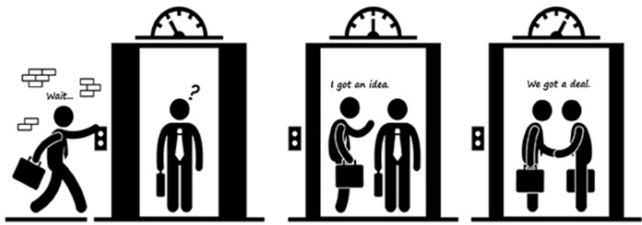
We help our clients________________________
through _________________________________
We do this by ____________________________.

Short Elevator Statement

I am your name .
I work (teach/educate/inspire/create, etc.) with ____(your niche) who struggle with
(want/can’t/are) _(your niche’s problem)_ and who want
(would like/need) __(your solution)______.

I am Vicki Winterton.
I work with small business owners just like you who struggle with office chaos and stress and want to move to order and calm. I supply that.

I am ____________________.
I work (teach/educate/inspire/create, etc.) with ___________________ who struggle with
(want/can’t/are) ______________________ and who want
(would like/need) _______________________.

