Planning Your Claim – FHEA (D2)
Use this worksheet to plan your Fellow of the Higher Education Academy (HEA) claim. This category of Fellowship is suitable for anyone who has a solid teaching background in higher education or who supports student learning more broadly (experienced advisors, instructional designers, instructional technologists, etc.).

D2 Requirements
Demonstrates a broad understanding of effective approaches to teaching and learning support as key contributions to high quality student learning. Individuals should be able to provide evidence of:

D2.I Successful engagement across all five Areas of Activity
D2.II Appropriate knowledge and understanding across all aspects of Core Knowledge

D2.III A commitment to all the Professional Values

D2.IV Successful engagement in appropriate teaching practices related to the Areas of Activity

D2.V Successful incorporation of subject and pedagogic research and/ or scholarship within the above activities, as part of an integrated approach to academic practice

D2.VI Successful engagement in continuing professional development in relation to teaching, learning, assessment and, where appropriate, related professional practices

Professional Standards Framework (UKPSF)
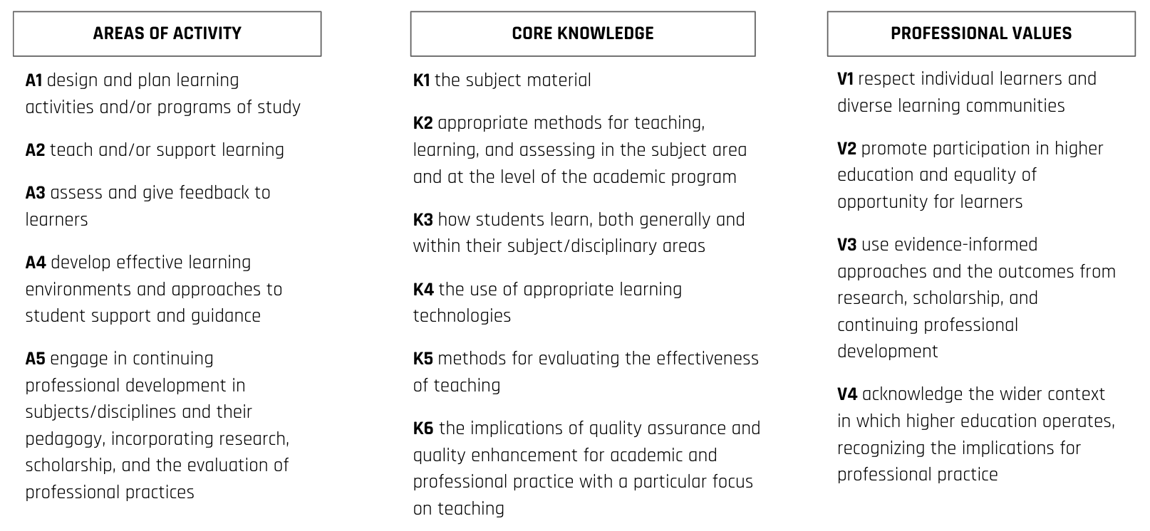

In the following worksheet, provide two examples of your teaching or professional practice and evidence of impact.
Areas of Activity | Your 2 best examples: | Which areas of Core Knowledge are associated | Which areas of Professional Values are associated | What is the evidence of impact
A1: Design and plan learning activities and/or programs of study
A2: Teach and/or support learning
A3: Assess and give feedback to learners
A4: Develop effective learning environments and approaches to student support & guidance
A5: Engage in continuing professional development in subjects/disciplines and their pedagogy, incorporating research, scholarship and the evaluation of teaching practice.

The D2 claim should include 5-8 examples of scholarship/research that informs your teaching or professional practice.
Citation or source | Brief description on how it informs your teaching or professional practice

