Planning Your Claim – AFHEA (D1)
Use this worksheet to plan your Associate Fellow of the Higher Education Academy (HEA) claim. This category of fellowship is suitable for anyone who doesn’t have an extensive teaching background, or who only teaches part-time (i.e. an Adjunct Professor). Associate Fellow is also suitable for anyone who supports student learning without directly teaching them (librarians, educational researchers, advisors, etc.)

D1 Requirements
Demonstrate an understanding of specific aspects of effective teaching, learning support methods, and student learning. You should be able to provide evidence of:

D1.I Successful engagement with at least two of the five Areas of Activity
D1.II Successful engagement in appropriate teaching and practices related to these Areas of Activity
D1.III Appropriate Core Knowledge and understanding of at least K1 and K2
D1.IV A commitment to appropriate Professional Values in facilitating others’ learning
D1.V Relevant professional practices, subject and pedagogic research and/or scholarship within the above activities
D1.VI Successful engagement, where appropriate, in professional development activity relates to teaching, learning, and assessment responsibilities

Professional Standards Framework (UKPSF)
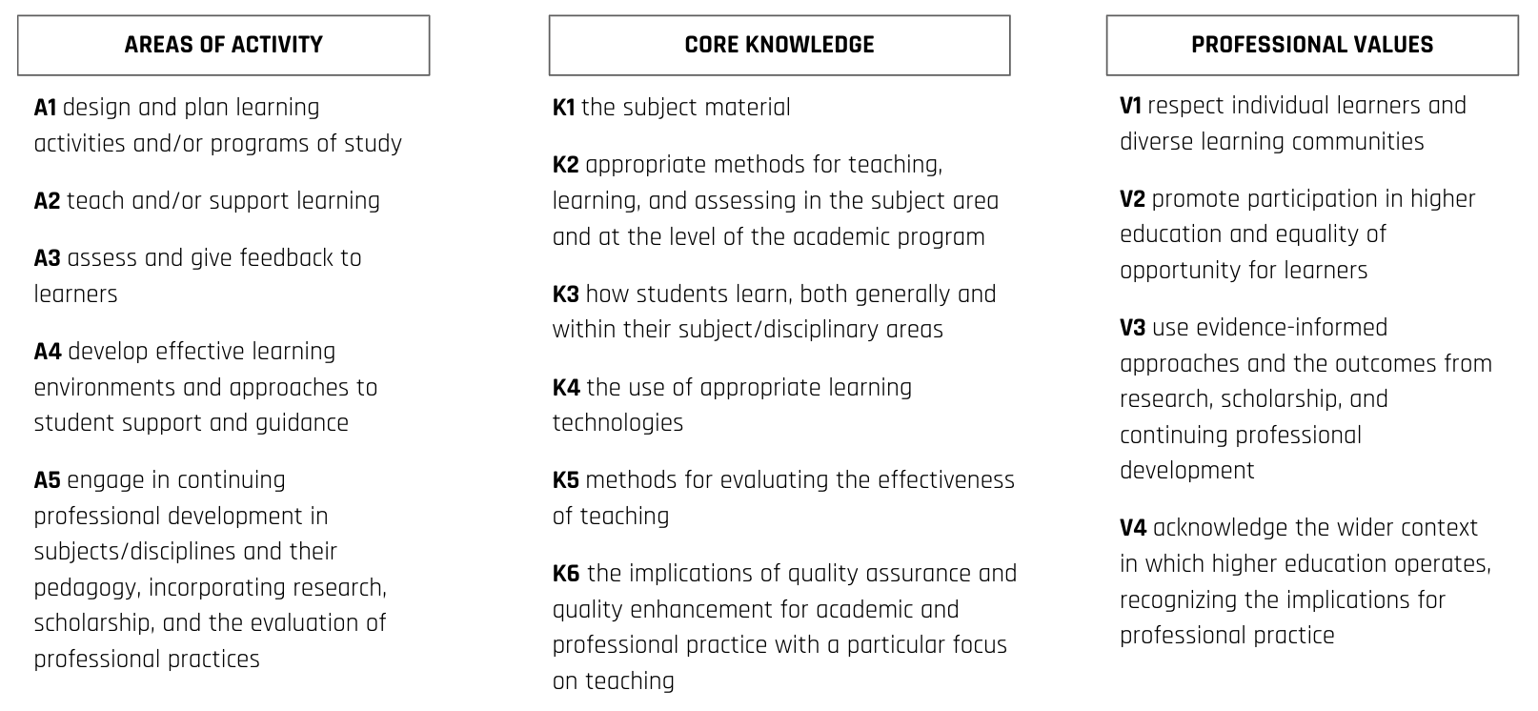

Provide two examples of you teaching or professional practice and evidence of impact.
Areas of Activity | Your 2 best examples: | Which areas of Core Knowledge are associated | Which areas of Professional Values are associated | What is the evidence of impact
A1: Design and plan learning activities and/or programs of study
A2: Teach and/or support learning
A3: Assess and give feedback to learners
A4: Develop effective learning environments and approaches to student support & guidance
A5: Engage in continuing professional development in subjects/disciplines and their pedagogy, incorporating research, scholarship and the evaluation of teaching practice.

The D1 claim should include 3-6 examples of scholarship/research that informs your teaching or professional practice.
Citation or source | Brief description on how it informs your teaching or professional practice

