Fall 2024

Oboe Excerpts

**Dvorak, Symphony No. 9 Mvt. II**

Please begin at Rehearsal 2 and play to 9th measure of Rehearsal 3.

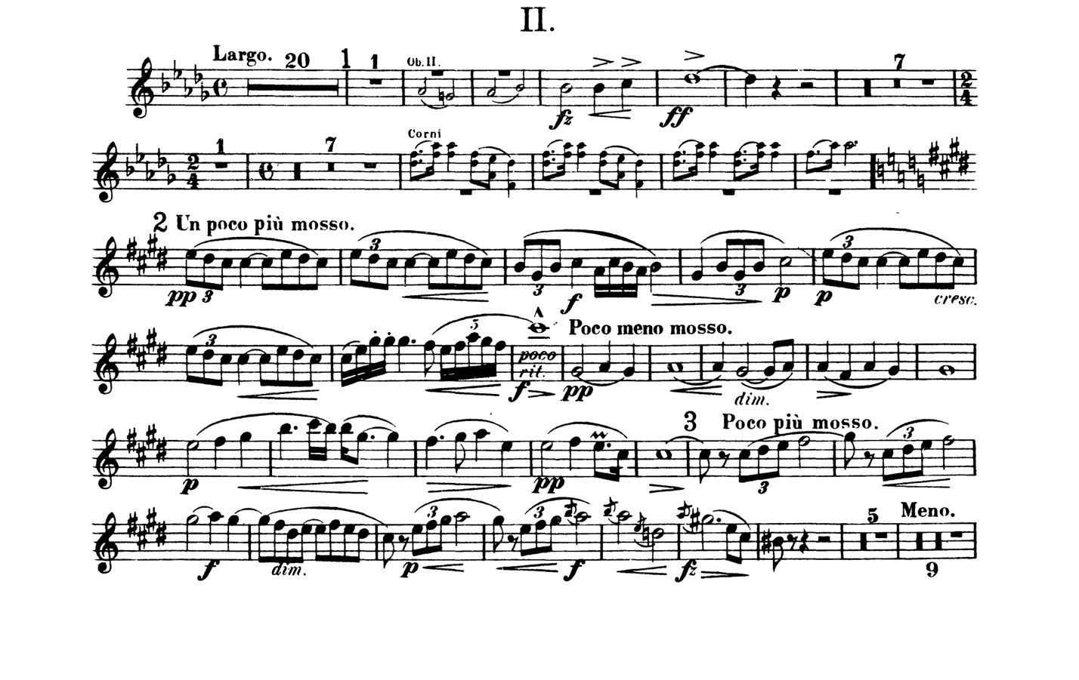

**Debussy, La Mer Mvt. II**

Please begin at Rehearsal 17 and play to Rehearsal 18. IMPORTANT: Please play the measure of second oboe when the first oboe line rests (3 measures before Rehearsal 18).

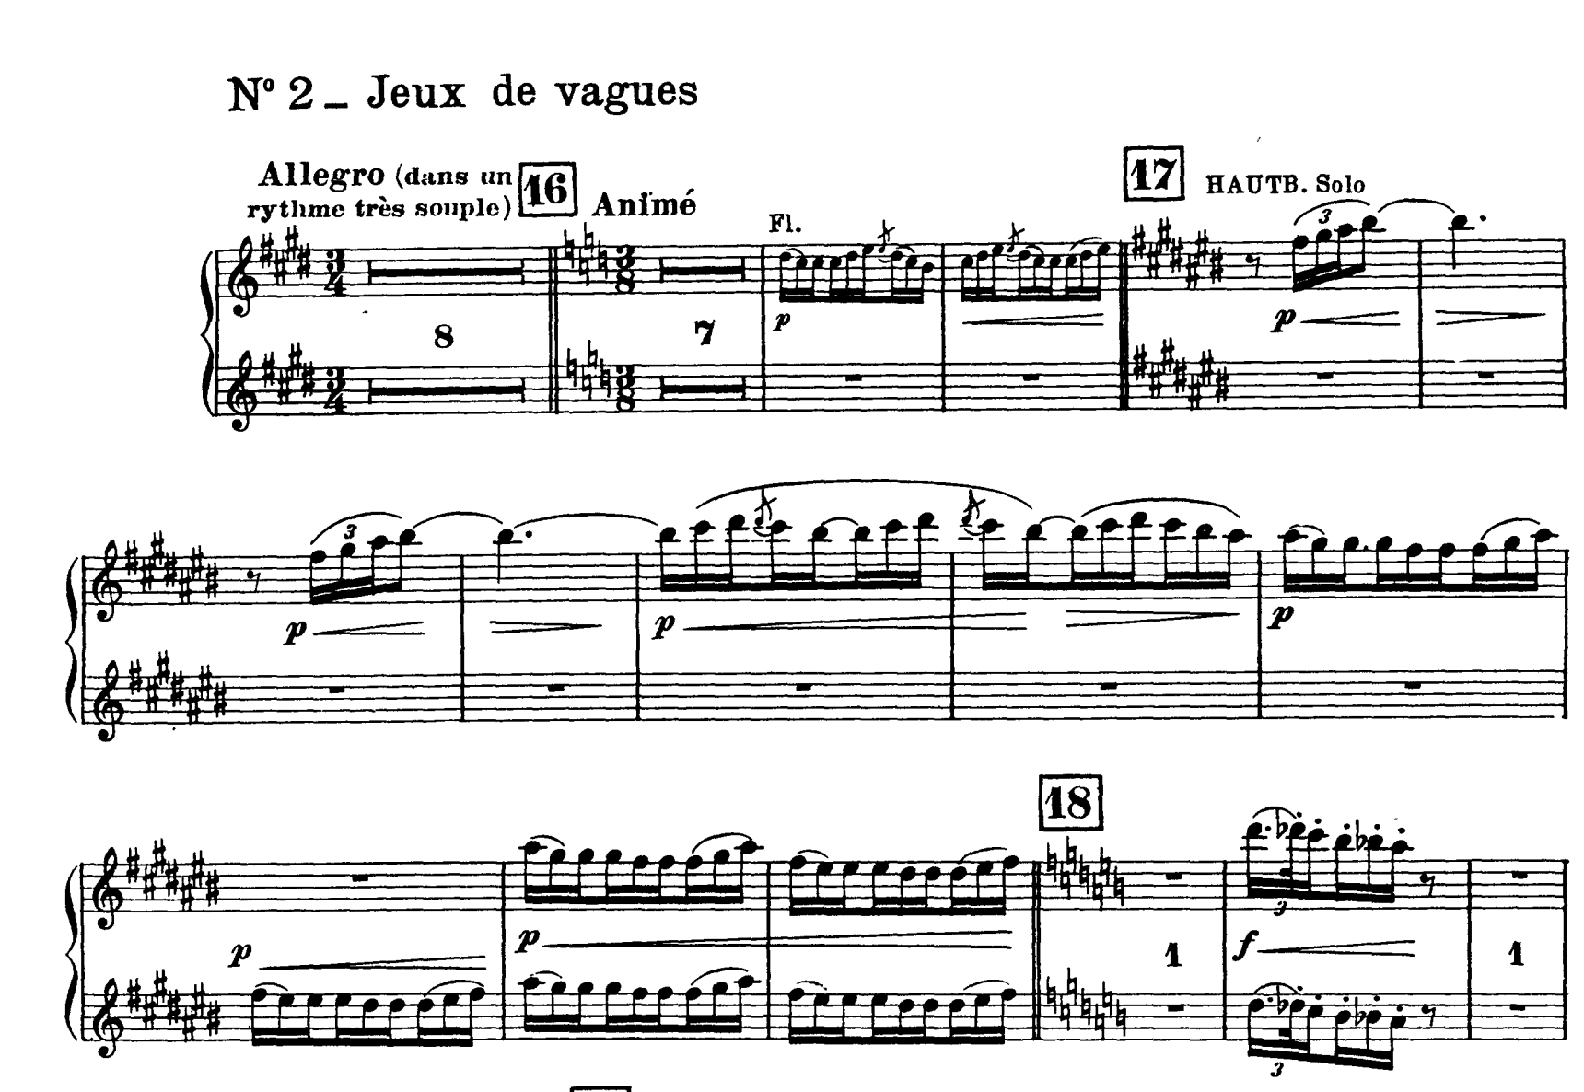

**Gounod, Petite Symphonie Mvt. I**

Please begin on the fourth bar of Rehearsal A and play through to Measure 40.

