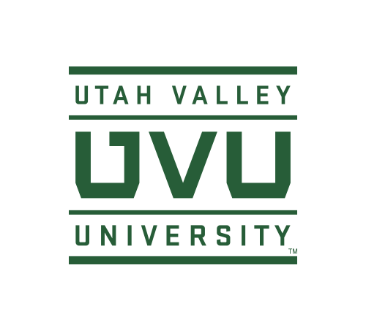
Faculty Senate Executive Committee Minutes
September 12, 2017
FL 516, 3:00-5:00 pm

Present: Pauli Alin, Jon Anderson, Clay Brown, Kat Brown, Karen Cushing, Lindsay Gerber, Dianne McAdams-Jones, Anthony Morris (Library), Jeff Olson, Craig Thulin, Sean Tolman
Visitors: John Curl
Excused or Absent: Howard Bezzant, Jim Pettersson
- Call to order – 3:40 PM
- Approval of Minutes from April 6 and August 29, 2017. Minutes approved.
Financial Aid – John Curl
- Significant change in Pell Grants awarded to our neediest students. Change is if student goes full-time fall and spring, they can receive an additional grant if they take at least six credit hours in summer. How long it will be in place is unknown. Estimating about 1500 additional summer students due to additional Pell funds. Will begin sending out notices and targeted messaging at the end of fall semester. Encourage students to follow-up with Financial Aid for additional information.
- New Pell Guidelines came primarily out of bipartisan support, not just the current President.
- Financial Aid restrictions placed on courses that students are eligible to take. Regulation is that Federal Financial Aid should only go to program courses of study. Has been difficult to manage in past. Currently testing program that will assist in monitoring program eligible courses. Pell Grant students must be enrolled in 12 credit hours towards their program of study. If a student is only federal loan eligible, they only need to be enrolled in six credit hours towards their program of study.
- ExCo decided to inform faculty regarding the updated PELL Guidelines and that federal mandates are already in place and need to be followed.
- Expectation is that UVU is working towards compliance.
Administrative Updates
SVPAA
- Gearing up for NWCCU Accreditation, PBA, Legislative Session, and more policies to approve. WSB has raised about $10M that will assist in determining their overall ranking with the State and Board of Regents.
- All departments need to update their RTP Criteria. Working on the Annual Faculty Review Template and recruitment of new faculty members. Will make funds available to broaden searches and obtain overall rich pools.
AVPAA
- Policy 638 – Post-Tenure Review – Asked to hold and not go forward to President’s Council this week. Post-Tenure Review Policy is in place, but currently on hold to address some of the changes.
- Annual Review Template goes with Annual Review Policy. New policy does show we have Annual Reviews with a due date of February.
- Encourage faculty to review the university mission and what it means in preparation for the NWCCU visit.
- RTP Faculty Committee – Faculty Senate owns the committee, but advises the SVPAA. Brown will work with Jim Pettersson on how the committee will function and collaborate with the SVPAA.
DEBATE
- Policies 654 – Faculty Merit Pay and 641 – Salaried Faculty Workload-Academic Year are in Stage 2.
DISCUSSION ITEMS
- Attendance at University Events (Freshman Convocation, Faculty Convocation, and Commencement) on what can be done to improve participation. McAdams-Jones conducted a straw poll in her college asking if faculty attended and, if not, why not. Reviewed received responses. Recommend Library do literature review to determine the impact on students if faculty participate in these events. Bring back to ExCo in two weeks for follow-up.
- Accreditation Site Visit – Thulin will be participating in a university review and not able to meet with accreditors if needed. Jon Anderson will handle in his place.
- ExCo would like to schedule a BBQ with President Holland and Faculty Senate. Cushing follow-up with Candice Gardner.
- OTL Faculty Advisory Committee – Gerber will follow-up with those schools/colleges who have not put forth nominations.
- Campus Visit to Senate – Anderson will follow-up with Hans-Joerg Tiede to determine his availability to come to UVU as a guest speaker.
- Campus Entity Presentations
  - John Curl re Financial Aid Updates
  - Jim Pettersson re RTP Advisory Committee
- Reviewed comments from Policy 654 – Faculty Merit Pay
  - Administration is trying to implement a policy for shared governance and allow faculty to participate in what the criteria will look like.
- Standing Committee for Review of Centers and Institutes – AAC is seeking a faculty member from each school/college and four external individuals to assist in a new committee to review all UVU centers and institutes for sustainability and effectiveness.
- Grading – Brown/Connelly/McAdams-Jones will create a one page practice document providing information on the grade appeals process and who students need to contact if they have a concern to be sure all parties (faculty, student, and ombudsman) have correct information.
- Reviewed agenda
- Meeting adjourned at 5:00 pm

