Biol 1615 – Semester Research Project

Objectives: At the end of this project, students will be able to…
- Utilize the scientific method as a tool for conducting research
- Understand and apply the steps of the scientific method
- Complete a scientific research project, utilizing all steps of the scientific method
- Apply knowledge of the nature of science and scientific practices to completion of a research project

The Scientific Method is an essential and foundational concept in scientific research. It’s not just something that you learn in school; it’s a practice that scientists live by. The purpose of the scientific method is to provide a logical approach to addressing phenomenon. As scientists, you will utilize the scientific method in order to complete a full research project over the next few weeks.

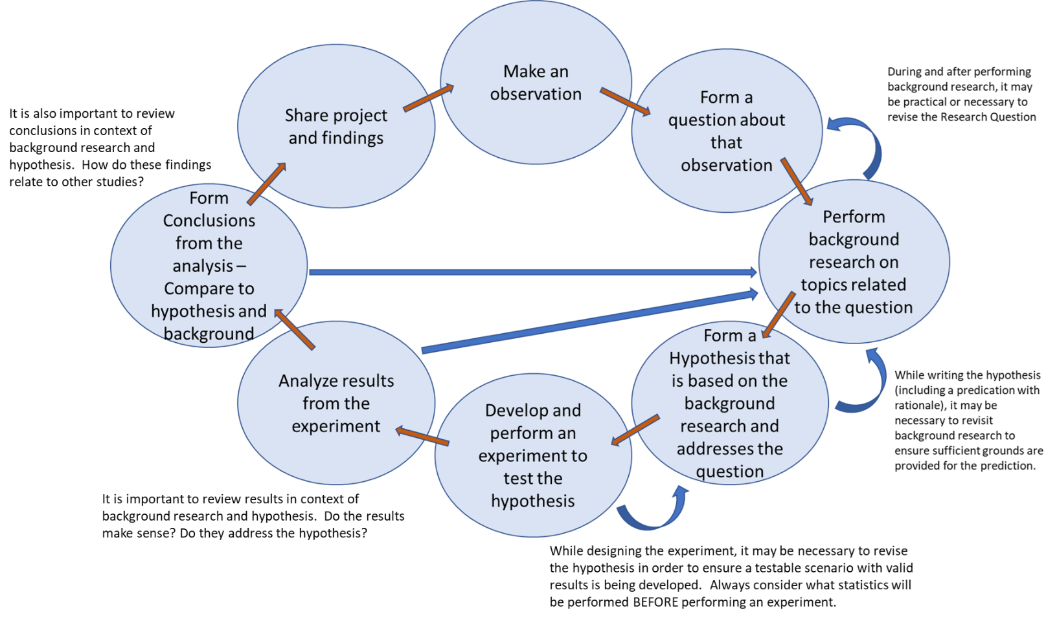
As a refresher, here are the steps of the scientific method:

This project will be divided over the length of the semester and weekly “check-ins” will be occur in addition to your lab worksheets. Other portions will need to be completed outside of class. The final product of your project will be a Lab Report and Presentation to the class.

As stated, portions of this project will be incorporated into your lab worksheets. It will be important to coordinate and collaborate closely with your group to ensure continued progress. It will be equally important to check with your instructor and review comments made on your lab worksheets. This will ensure that you are on the right track and progressing toward a satisfactory final product.

Below, you will find a short summary of what portions of the Scientific Method you should be focused on with each week. There is a bit of flexibility, but it is important to stay up-to-date in order to ensure completion on time.
Week 1 – Introduction of project. Begin thinking about possible topics.
Week 2 – Make an observation and decide on a topic for your project. Form a Question based on your observations
Week 3 – Background research generalized around your research topic
Week 4 – Background research directed at your research question – Begin forming hypothesis
Week 5 – Finalize Hypothesis and write a rough experimental design – Submit to instructor for approval
- PROVIDE A SUPPLY REQUEST LIST TO YOUR INSTRUCTOR. *Note that this may be rejected if items are unable to be obtained due to excessive cost, difficulty of procurement, safety concerns, or practicality of your experimental design
- Supplies should be things easily obtained from local stores or already present in the labs (check with your lab instructor if you aren’t sure)
- Requests MUST include EXACT specifications of what item(s) you need and how much
- It is recommended to write the Introduction section of your Lab Report during the first 5 weeks
Week 6 – Finalize Experimental Procedure, decide type of data to be collected and how it will be analyzed
Week 7 – Perform Experiment (supplies provided by this date – if setup is required in advance, you must coordinate it with the Lab Manager)
- It is recommended to write the Methods section and begin on the Results section of your Lab Report during weeks 6 and 7
Week 8 – Analyze Results/Form Conclusions
- It is recommended to write the Results and Discussion sections of your Lab Report during week 8
Spring Break - this is a free week, but it is recommended to use this week to catch up if you’ve fallen behind for any reason
Week 9 – Revise and review lab report – We will do an in-class peer review of lab reports. Bring 4 printed copies of your lab report to class!
Week 10 – Lab report due
Week 11 – Prepare Final Presentation
Week 12 – Revise Final Presentation based on Lab Report feedback
Week 13 – Final Presentations Due

Arguably, the most difficult part of this project will be deciding on a research topic and question. Feel free to use any resource that you have available for guidance; look up ideas on the internet (preferably from reputable sources), look through faculty research topics, ask friends, adjust a project from another class, etc.
Your topic can be anything within the field of Biology; microbiology, cells, genetics, physiology, evolution, photosynthesis, cellular respiration, forensics, agriculture, botany, etc. Be Creative.

Some things to keep in mind:
- Your project should follow a logical progression. In other words, each step of the scientific method should be used to inform the next step. Your hypothesis should be based on your question and background research. Your experiment should make sense in regards to your hypothesis and background research.
- You will need to consider appropriate treatments, lengths of trials, and number of repetitions.
- Time limitations. You will have all semester to complete the overall project, but will have several due dates and worksheets along the way. Ensure that you are keeping up with the project throughout the semester.
- More time limitations. You will also need to consider your actual experiment. You will be provided one full class period to perform your experiment. However, you may design something that needs more time or requires checking in on over the course of a few days/weeks. This is fine as long as it’s something that you can actually accomplish within the confines of the semester.
- Space limitations. There is not much room available to set-up and maintain long term experiments. You should either plan to complete your entire experiment in one lab session OR outside of class
- Data Data Data! You will need to perform a statistical analysis on your data. There are means to perform qualitative analyses, but for our purpose, you should be taking QUANTITATIVE measurements in order to perform one of the following analyses:
  - Paired or Unpaired T-Test (pre/post tests and comparing 2 treatments)
  - One-way ANOVA (comparing 3 or more treatments)
  - Regression (showing a relationship between two variables such as growth over time)
- The earlier you can provide your instructor with a supply list, the more likely it will be to get those supplies. You will need to justify any/all items that you request. If the lab staff is unable to procure your requests for any reason, adjustments may need to be made to your experimental design.
- READ THE RUBRICS! A few project points will be worked into lab worksheets, but the VAST majority of points will come from the Lab Report and Presentation. Read the rubrics so that you know what you will be graded on.
- What do you do if your experiment doesn’t work? That’s science! Report what happened and any explanation you can offer. Work with your instructor to compensate for unforeseen issues. Note that if you aren’t keeping up with the project as the semester progresses, there will not be as much that can be done to help when issues arise. We’ll do what we can, but some issues go beyond our abilities to correct. If you are working closely with your instructor throughout the semester, then you’re less likely to run into problems later on.

Probably write these are second worksheets on Canvas for each week…. Check-ins worth 10% of overall grade, Lab Report is another 10%, Presentation is another 10%???

Student Designed Project Check-in - Week 1
Exploring Research Topics
- I understand the overall concept and objective of the project (1 point):
  - Yes
  - No
    - If no, what questions do you have?

- What topics in Biology interests you? What areas do you think you could design a research project in? Note: feel free to look up areas of biology online – a good place to start may be the “About us” page on the UVU Biology department webpage. You can also look here: https://www.bioexplorer.net/divisions_of_biology/ (4 points)

Student Designed Project Check-in - Week 2
Choosing Research Topic
- What area of study are you planning on completing your research project in? (2 points)
- List 10 observations about the above area of study (these can be from internet research, life experience, or previously known bits of information). (5 points)
- Narrow down your observations. Form 3 possible research questions based on any of the observations above. (6 points)

Student Designed Project Check-in – Week 3
Continue background research and finalize Research Question

- Cite 1 PRIMARY publication that provides useful information about the overarching topic of your project. (2 points)
- Based on preliminary background research, choose one of your research questions from last week to focus on for your project (you may come back to another one if the one you choose leads to a dead-end). What is your research question? (1 point)
- Cite 1 PRIMARY publication that provides useful information about your chosen research question. This can NOT be the same article cited in question 1 (2 points)

Student Designed Project Check-in – Week 4
Continue Background Research and begin to form Hypothesis
- Cite a DIFFERENT primary or secondary publication that provides useful information regarding your Research Question.
- Based on the background that you have found over the last few weeks, what are you testing? In other words, turn your research question into a statement of what you plan to do.
- Based on your background research, what do you predict will happen?
- What evidence do you have to support that prediction (should be from the publications you found)?
- Write a rough draft of a hypothesis using evidence from question 4 and your prediction from question 5.
- Over the next week, you should plan your experimental design. What set-up will you need? What equipment will you need? What supplies will you need? Keep in mind that anything too expensive or difficult to obtain on short notice will be denied. Ask your instructor about things we have in the labs and whether or not particular items may be infeasible.
- You should feel free to look for resources around campus and the community – sports teams, community groups, and other academic departments are often happy to provide assistance (and research subjects)

Student Designed Project Check-in – Week 5
Finalize Hypothesis and write Experimental Design
- You wrote a rough hypothesis last week. Review what you wrote and check to see if your instructor provided any comments/ feedback. Write a final hypothesis. (2 points)
- What is your independent variable?
- What is your dependent variable?
- What is your control treatment?
- Write a step-by-step outline of your experiment.
- Provide a list of supplies that your group will need in order to complete your experiment - Supplies should be things easily obtained from local stores or already present in the labs (check with your lab instructor if you aren’t sure)
  - Be aware that certain items may be denied if they are too expensive, difficult to obtain, or otherwise infeasible – HAVE A BACKUP PLAN IF YOU HAVE ANY DOUBTS!

Student Designed Project Check-in – Week 6
Review supply approvals, finalize experimental design
- Your supply list has been reviewed by the lab staff. Review the approvals and also see if your instructor has made comments on your experimental design from last week. Decide if adjustments need to be made to your experiment. Do you need to revise? If so, what changes will you make?
- What statistical analysis will you perform on your results?
- The next week is flexible depending on your experiment
  - Final supply requests may not be available until the day of your lab but might be ready early – check if you need something earlier
  - If you plan to complete your experiment in the lab, come to class as usual
  - If you plan to complete your experiment on your own, you don’t need to come to class next week
  - If you require access to the lab to check on progress of your experiment over the course of several days, notify your instructor IMMEDIATELY and make arrangements with the lab staff
  - If you need lab staff to set-up anything for you prior to next class, notify your instructor immediately and make arrangements with the lab staff.

Student Designed Project Check-in – Week 7
Perform Experiment
This week is flexible depending on the needs of your experiment – notify your lab instructor IMMEDIATELY if any changes or adjustments need to be made. Note that accommodations may not be possible without sufficient notice.
- It is recommended to write the Methods section and begin on the Results section of your Lab Report during weeks 6 and 7
- Create a table that includes all results of your experiment

Student Designed Project Check-in – Week 8
Analyze Results/Form Conclusions
- Perform statistical analysis on your results (probably an ANOVA, but this is not necessarily the case). What is your p-value? Should you reject or accept your hypothesis?
- What are your standard deviations? What do these tell you about your data? Refer specifically to YOUR data - In other words, don’t just tell me what a standard deviation is. Tell me what YOUR deviations mean in respect to your results.
- Were there any surprises in your results or experiment? What sources of error might have influenced your results? How might they have done so?
- How do your findings compare to information you found while performing your Background Research? Does it make sense? Explain.
- Considering your results, what would you propose as your next project if you were to do another round of this assignment now?

It is recommended to write your Results and Discussion sections during week 8 – All parts of the Lab Report should be completed BEFORE class on week 9.

Student Designed Project Check-in – Week 9
Peer review
- Based on the peer-review completed in-class, make a BREIF summary of the changes and updates that you plan to make before submitting your Final Draft.

The Final Draft of the Lab Report is due BEFORE class on week 10 – it is recommended to work on your presentation on weeks 9 and 10.

Student Designed Project Check-in – Week 10
Final Draft of Lab Report Due

Student Designed Project Check-in – Week 11 and 12
Review Instructor comments/feedback on Lab Report (once graded), work on Final Presentation

Final Presentation is due on Week 13

